Linda Mei

Final Project: Piece 3 (Part 2) Octave Plotter, Salter, and Smoother

I took my existing equation, graph ranges, and salting ranges directly from my Project 1’s Graph program to ensure that I get similar results when I program in Octave. Though this time, I did change my smoothing ranges so that it would look smoother in Octave. I took 25% of the maximum range of points (100 points for run 1 and 10000 points for run 2) and used that as the sliding window length.

**Plotter Graph 1**

Equation: y = 6x+9

Range: 1 - 100 points

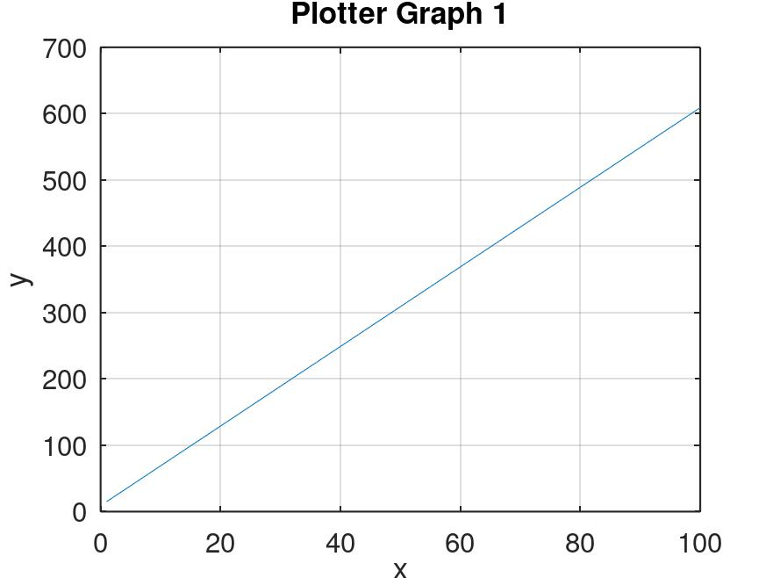

**Salter Graph 1**

Salted the y-values with a random range of 25 to 60

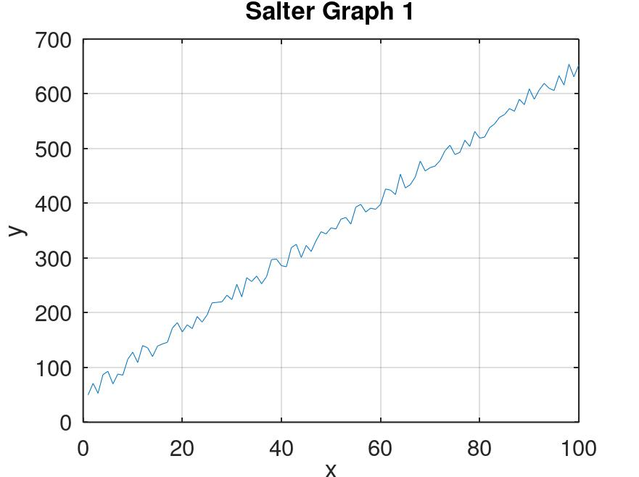

**Smoother Graph 1**

Smoothed the graph (sliding window length: 25)

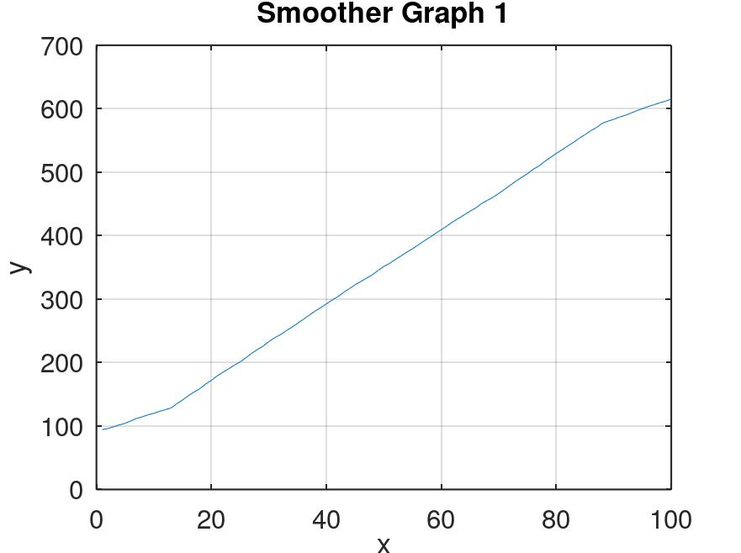

**Plotter Graph 2**

Equation: y = 6x+9

Range: 1 - 10000 points

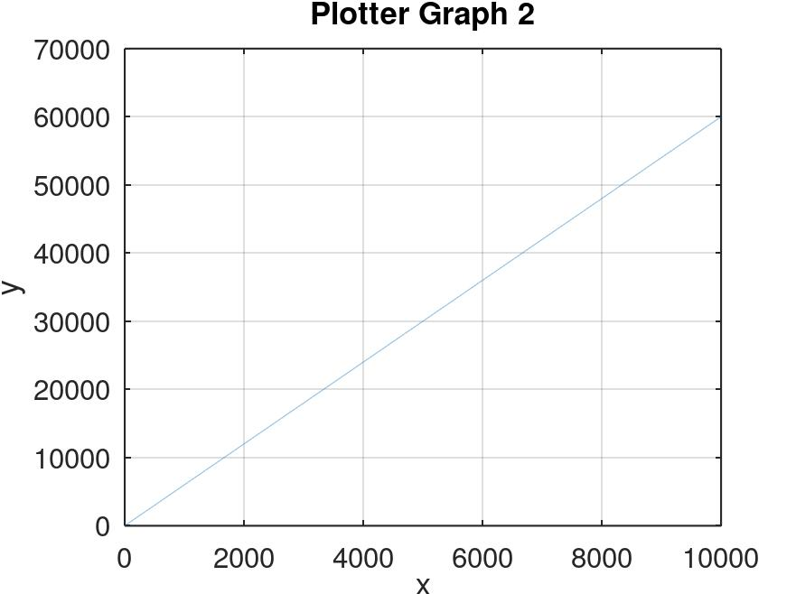

**Salter Graph 2**

Salted the y-values with a random range of 2500 to 7500

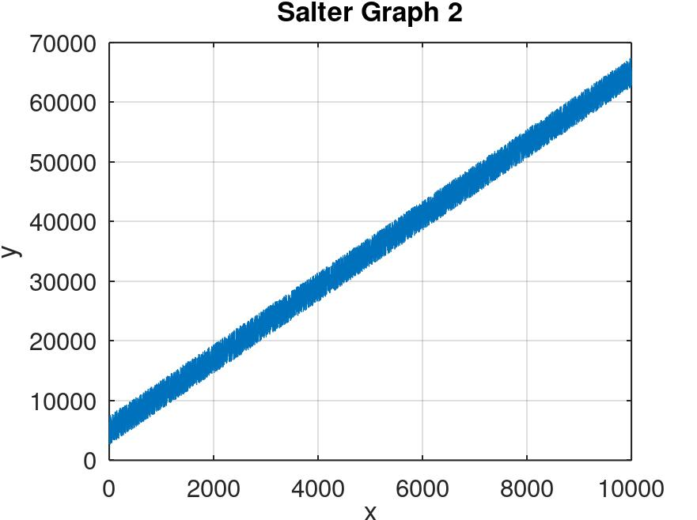

**Smoother Graph 2**

Smoothed the graph (sliding window length: 2500)

